**Experiment : 1.1**

**Student Name: SANJIV GUPTA UID:** 21BCS-*3478*

**Branch:** CSE **Section/Group:** 21BCS-IOT-602B

**Semester:** 5th **Date:** 17/08/23

**Subject Name**: Advanced Programming LAB **Subject Code:** 21CSP-259

**AIM:** *To implement the concept of Array.*

**OBJECTIVE:**

1. *Given an array, A of N integers, print A's elements in*reverse*order as a single line of space-separated numbers.*
2. *The objective is to develop a program that takes the ratings of two challenges created by Alice and Bob, compares the ratings for each category, calculates their scores, and produces a list representing the comparison points, with Alice's score first and Bob's score second.*
3. *Print the sum of the array's elements as a single integer.*

**CODE:**

**Code 1:**

*#include<iostream>*

*using namespace std;*

*void reverse(int arr[],int size){*

*int start = 0;*

*int end = size-1;*

*while(start<end){*

*swap(arr[start],arr[end]);*

*start++;*

*end--;*

*}*

*cout<<"The reverse array is: ";*

*for(int i = 0; i<size;i++){*

*cout<<arr[i]<<" ";*

*}*

*}*

*int main(){*

*int arr[100];*

*int size;*

*cout<<"Enter the size of array: ";*

*cin>>size;*

*cout<<"Enter the element: ";*

*for(int i=0;i<size;i++){*

*cin>>arr[i];*

*}*

*reverse(arr,size);*

*}*

**Code 2:**

*#include<iostream>*

*using namespace std;*

*int main(){*

*int a[100];*

*int b[100];*

*int size;*

*cout<<"Enter the size of array: ";*

*cin>>size;*

*cout<<"Enter the elements for alice: ";*

*for(int i =0;i<size;i++){*

*cin>>a[i];*

*}*

*cout<<"Enter the elements for bob: ";*

*for(int i=0;i<size;i++){*

*cin>>b[i];*

*}*

*int aScore=0;*

*int bScore=0;*

*for(int i=0;i<size;i++){*

*if(a[i]>b[i]){*

*aScore = aScore+1;*

*}*

*if(a[i]<b[i]){*

*bScore = bScore+1;*

*}*

*if(a[i]=b[i]){*

*aScore = aScore;*

*bScore = bScore;*

*}*

*}*

*cout<<"Alice Score: "<<aScore<<endl;*

*cout<<"Bob Score: "<<bScore<<endl;*

*if(aScore>bScore){*

*cout<<"Alice Won"<<endl;*

*}*

*else if(aScore==bScore){*

*cout<<"Draw"*

*}*

*else{*

*cout<<"Bob won"<<endl;*

*}*

*}*

**Code 3:**

*#include<iostream>*

*using namespace std;*

*int main(){*

*int arr[100];*

*int size;*

*cout<<"Enter the size of array: ";*

*cin>>size;*

*cout<<"Enter the element: ";*

*for(int i=0;i<size;i++){*

*cin>>arr[i];*

*}*

*int sum=0;*

*for(int i=0;i<size;i++){*

*sum+=arr[i];*

*}*

*cout<<"Array sum is: "<<sum;*

*int finalSum=0;*

*while(sum>0){*

*int digit = sum%10;*

*finalSum+=digit;*

*sum = sum/10;*

*}*

*cout<<"\nFinal Sum: "<<finalSum;*

*}*

**OUTPUT:**

**OUTPUT 1**

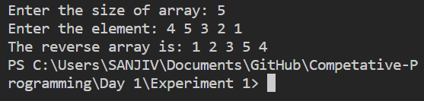

**OUTPUT 2**

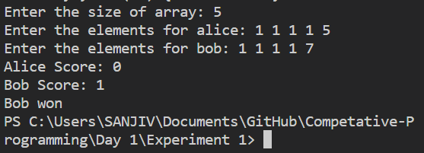

**OUTPUT 3**

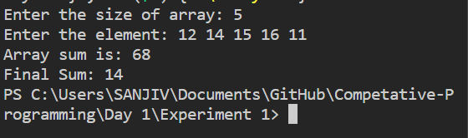

**LEARNING OUTCOMES:**

1. *Learn about array manipulation technique.*
2. *Learn about array conditional logic.*
3. *Learn about algorithm thinking*
4. *Learn about mathematical logic*